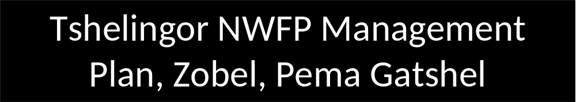

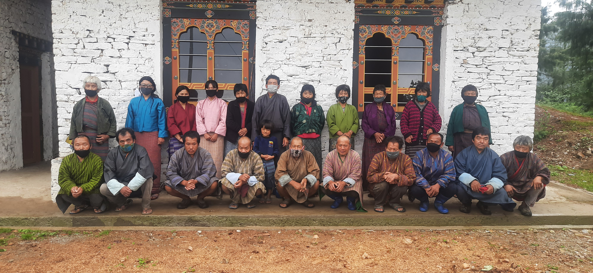
Plan period: 2022 – 2026
Village: Tshelingor
Gewog: Zobel
Dzongkhag: Pema Gatshel

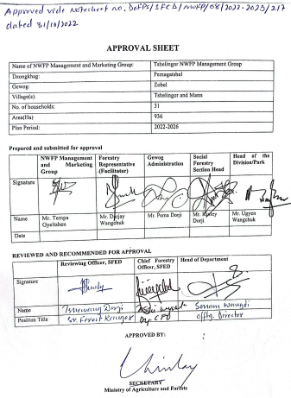

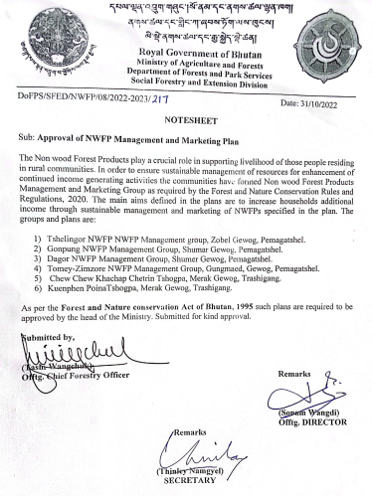

GLOSSARY AND ABBREVIATIONS

CFD Community Development Fund
CFO Chief Forest Officer
DoFPS Department of Forests and Park Services
DT DzongkhagTshogdue
GFEO Gewog Forestry Extension Officer
GT Gewog Tshogdue
HHs Households
NWFPs Non Wood Forest Products
ToR Terms of Reference

Contents
EXECUTIVE SUMMARY 3
PART 1: BACKGROUND INFORMATION 4
1.1: Short descriptions of Lanyee roo (Rubia cordifolia) 4
1.2: Brief descriptions of Silung Shing (Parasassafras confertiflora) 5
1.3: Brief descriptions of Nyaishing jorma (Viscum nepalense) 5
1.4: Brief descriptions of Youngjiba (Pouzolzia sanguinea) 6
1.5: Brief descriptions of Shogo Shing (Daphne bholua) 6
1.6: Brief descriptions of Ngon Changlu (Swertia chirata) 7
PART 2: NWFPS MANAGEMENT AND MARKETING PLAN 8
2.1: The objectives of the management plan are given below: 8
2.2: NWFPs descriptions 8
Yongjiba (Pouzolzia sanguinea) 8
Silungshing (Parasassafras confertiflora) 8
2.3: Harvesting prescriptions for sustainable NWFP harvesting 9
2.4. Sketch map of the NWFP harvesting area 10
2.5: Marketing and sales plan 11
2.5. Collection and Marketing arrangement with the group and traders 12
2.6: Marketing arrangements 12
PART 3: BY-LAWS GROUP REGULATIONS AND NORMS 13
3.1. Members of the NWFP management & marketing group 13
3.1.1. Eligibility criteria to become member 13
3.1.2. Admission procedures for new members 13
3.1.3. Resignation of members 14
3.2. Committee members 14
3.3. Terms of reference for committee members 14
3.3.1. Responsibilities of Committee / Chairperson: 14
3.3.2. Responsibilities of Secretary: 15
3.3.3. Responsibilities of Treasurer: 15
3.3.4. Responsibilities and rights of members: 15
3.3.4. Resignation of committee members 16
3.3.5. Termination of committee members 16
3.4. Compensation to the committee or any other office bearers 16
3.5. Membership fee and purpose 16
3.6. Community development fund and utilization of fund 16
I. Income contribution to group fund 16
II. Fund management 16
III. Fund utilization 17
3.7. Conflict Resolution 17
3.8. Offences and Penalties 17
Members list 18
3.9. Past five years NWFP Harvesting Record for the group 20

Figures
Fig 1: Rubia cordifolia 4
Fig 2: Parasassafras confertiflora 5
Fig 3: Viscum nepalense 5
Fig 4: Pouzolzia sp. 6

Tables
Table 1: Block description of individual NWFPs species 9
Table 2: Harvesting prescriptions for sustainable NWFP harvesting 10
Table 3: Marketing and sales plan of NWFPs 12

EXECUTIVE SUMMARY
Tshelingor Non-Wood Forest Products (NWFP) Management Group comprised of 31 members covering two villages of Tshelingor and Mann. The Tshelingor Chiwog lies under Zobel Gewog of Pema Gatshel Dzongkhag. It is located around 41 km away from Dzongkhag Administration and it is connected with 7 km farm road from Ngangshing Village. This management plan is revised after completion of first 5-year plan period (2015–2020) of by the NWFP group.
During the past 5 years the members managed to collect around 800 kgs of NWFP products which helped them generate income to meet their expenses to busy basic groceries. They also faced challenges in managing the resources due to lack of knowledge on record keeping, marketing and product developments. There was no specified mapped area for collection in the past and often led to conflict over collection area with adjoining villages.
However the revised plan was prepared in consultation with the members to ensure sustainable management and utilization of these resources without compromising the income of the members. According to recent resource assessment it showed that there is potential for harvesting 6 species of NWFP although the members had collected only three species of NWFP Rubia cordifolia, Pouzolzia sanguinea and Viscum nepalense during past plan period. These resources can be collected from the designated collection area mapped using GPS in the NWFP management plan.
The Management Plan consists of the brief description of NWFPs, descriptions of individual species including harvesting prescriptions, sketch map of NWFPs harvesting areas and marketing sales plan. The by-laws of the management plan contained process of committee formation -ToR of Chairperson, Secretary and Treasurer, compensation to the committee for marketing, membership fee and community development fund, conflict resolution and penalties.
The term of management plan is for five years and will be effective from 2022 to 2026. During the period, the members will have right to collect mentioned NWFPs as per the harvesting guidelines prescribed in the plan and ensure sustainability of resources in the future.

PART 1: BACKGROUND INFORMATION
Tshelingor Non- Wood Forest Products (NWFP) Management Group had collected only three species of NWFP products during the past management plan period. They collected Rubia cordifolia, Pouzolzia sanguinea and Viscum nepalense to generated income for the members. Amongst three species they generated income mostly from Rubia cordifolia followed by Pouzolzia sanguinea. The group didn’t focus on the rest of the species they found potential during the commencement of the group in 2015.
No illegal harvesting and forest fire incidence were recorded because of extensive patrolling by the NWFP Group members. Despite lacking capacities and development training, the annual meetings, group activities, fee collections are done timely and fair record keeping system was practiced.
During this revision period, around 6 species of NWFPs are found to have potential for the group to generate the income. These resources will be collected from the specified areas designated for collection and management in this plan period.

1.1: Short descriptions of Lanyee roo (Rubia cordifolia)

Rubia (local name Laniru) is a perennial scrambling or climbing herbs or sub-shrubs of around 80 species native to various parts of the world. It can grow up-to 1.5 m in height. The evergreen leaves are 5-10cm long and 2-3cm broad, produced in whole whorls of 4-7 star like around the central stem. It climbs with tiny hooks at the leaves and stem. The flower usually appears from June to August. It grows along the forest edge and clearings, scrub vegetation, dune forest, less commonly in grassland and open and rocky areas. It grows up to the elevation of 2600 masl.
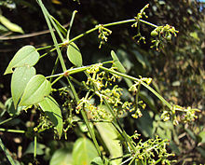
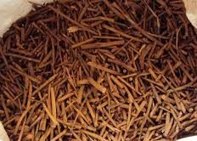
Fig 1: Rubia cordifolia

Figure 1: Rubia cordifolia

Uses
Rubia is used as a colourant especially for paints. In Bhutan Rubia is used to ward off the evil spirit, which cause severe body ache and used as a dye to colour the thread.

1.2: Brief descriptions of Silung Shing (Parasassafras confertiflora)

P. confertiflora is a deciduous tree, which distributed mainly in tropical and subtropical regions of those countries. The genus P. confertiflora belongs to family Lauraceae which is known for high seed oil content but report on oil production and its uses are limited. In Bhutan, the plant is found in altitude ranges from 900-2150 m, where Tshelingor area fall within this range and this species thrives well in the area

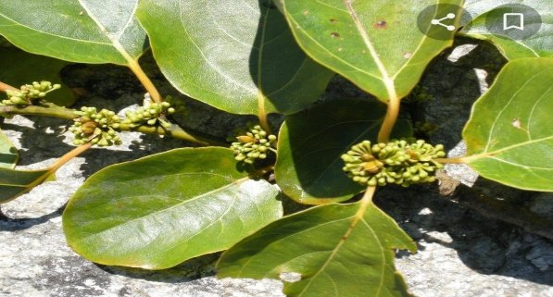

Fig 2: Parasassafras confertiflora

Uses
The extracted oil is used for the medicinal purpose and home consumption. The oil is said to be very nutritious for consumption if limitation is known. The seed oil is mainly used in injuries, cracked skin and blisters of both human and animals. Sometimes the oil can be applied to the body parts repel parasites and harmful insects from body parts.

1.3: Brief descriptions of Nyaishing jorma (Viscum nepalense)

Viscum nepalensis is a leafless hemi-parasitic mistletoe found growing on the branches of Cool Broadleaved trees. The leaves are visible only in the very young internodes as small bract below the flowers. It habitats mostly in the temperate region of our country. In Tshelingor it can be seen in the Community Forest area and NWFP sites of Tshelingor NWFP Group.
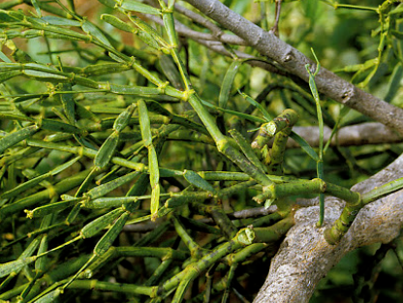
Fig 3: Viscum nepalense

Uses
The plants are used to produce locally prepared tea leaf

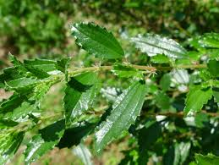
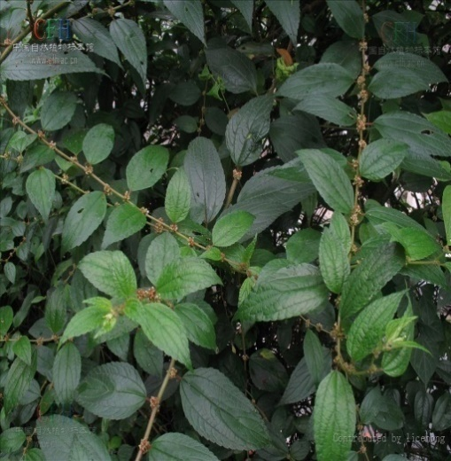
1.4: Brief descriptions of Youngjiba (Pouzolzia sanguinea)
Fig 4: Pouzolzia sp.

There are 35 Pouzolzia species widely spread from Bhutan. It is an evergreen shrubs growing in warm broad leaved forests, thickets and edge of woods, dry valleys, roadside and in the patches of abandoned cultivation at elevations of 300-2300masl. In Tshelingor area it is found at the elevation of 1602 – 1966 masl.

Uses
A paste made from the roots of Pouzolzia is applied to boils. A fiber obtained from the barks is used to make rope, nets, etc. In Bhutan, it is popularly used as an important raw-material in incense manufacturing process.

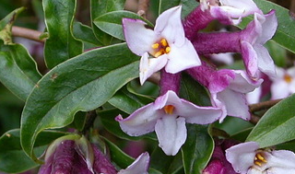
1.5: Brief descriptions of Shogo Shing (Daphne bholua)
Fig 5: Daphne bholua

Daphne bholua, the paper plant is the species of flowering shrubs in the Thymelaeaceae family. It grows at the altitude of 1700 m to 3500 m in Himalayas in Bhutan, Nepal and China. In some extend it can grow up to the height of 4 m in height

.

Uses
In Bhutan it is used in traditional paper making. The fibre in the inner bark is used to make rope. Some parts of bark and roots are used in medicine to treat fevers.

1.6: Brief descriptions of Ngon Changlu (Swertia chirata)

Swertia chirata is annual herbs under the genus swertia in the family Gentisnaceae. It grows at high altitude in the sub temperate of Bhutan. It habitats at the height between 1200 m and 2100 m altitude from Kashmir to Bhutan. It is found in and around the Tselingor village.
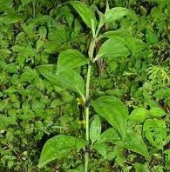

Uses
Swertia chirata is used as an ingredient in a number of herbal remedies. Amongst many species of Swertia species Swertia chirata is considered the most important for its medicinal properties. It is used by the local people for the treatment of inflammation and digestive diseases. For wide range of medicinal treatment, it can be used as a treatment for chronic fever, malaria, anemia, asthma, skin diseases, ulcer, blood purification and diabetes.

PART 2: NWFPS MANAGEMENT AND MARKETING PLAN

2.1: The objectives of the management plan are given below:
- To manage the NWFPs sustainably at local level through community participation.
- To enhance income generation of the community through sale of NWFPs.
- Equitable sharing of income among the members

2.2: NWFPs descriptions

Table 1: Block description of individual NWFPs species
NWFP name | Collection area (name) | Parts harvested | Use purpose (traditional and others) | Harvesting season (months) | Estimated quantity that can be collected
Yongjiba (Pouzolzia sanguinea) | Tshalarimung  Tshalari  Golshing Brangsa  Dokhamann | Bark | Adhesive incense | August to February | 500 kg
Lanyee roo (Rubia cordifolia) | Ngangshingwog  Dhokha Mann  Tsheingkhor | Entireplant | Dye and Medicine | November to February | 1000 kg
Nyaishing Jurma (Viscum nepalense) | CF  Dokha Mann  Juka Brangsa  Lungten Phu | Whole Plant | Medicine | November to February | 10 kg
Shogoshing  (Daphne bholua) | CF  Lungten Phu | Bark | Traditional Bhutanese Paper Making | March to June | 1000 kg
Silungshing (Parasassafras confertiflora) | Juka Brangsa | Fruit | Oil production | July to August | 100 kg
Ngonchanglu (Swertia chirata) | Mann  Tshalari Mung | Whole plant | Medicinal | November to January | 200 kg

2.3: Harvesting prescriptions for sustainable NWFP harvesting

Table 2: Harvesting prescriptions for sustainable NWFP harvesting
NWFP species | Harvesting prescriptions for sustainable harvesting
Youngjuva (Pouzolzia sanguine) | • Cut the plant at 10 cm above the ground level (the left stump will coppice in the following growing season).  • Do not damage the remaining young stands/ seedlings/ saplings  • Felling of surrounding trees to ease harvesting is prohibited.  • Leave at least 10% of the plants to allow natural regeneration.  • Collection of roots is strictly prohibited for ecological reasons
Lanyee roo (Rubia cordifolia) | • Use sharp scissors for the harvesting of the upper part of the plant.  • Cut the plant at 5 cm above ground level.  • Leave at least 10% of the plants without collecting or harvesting any raw materials from them (these plants shall act as seed plants for natural regeneration).  • Do not collect roots.  • Do not uproot entire plants
Nyaishing Jurma (Viscum nepalense) | • It will be collected only if it is available in abundance  • No felling of trees will be allowed for the collection
Shogoshing  (Daphne bholua) | • Cut the plant at 10 cm above the ground level (the left stump will regenerate in the following growing season).  • Cut only stems that are more than 3 cm in diameter.  • Do not damage the remaining young stands, seedling and /or saplings  • Do not fell the surrounding trees in order to clear the area to ease harvesting  • Divide harvesting area into 5 blocks for Daphne. Harvesting area is rotated over the 5 blocks to ensure that harvesting takes place only in one block per year (Daphne takes 5 years to produce stems of more than 3 cm in diameter).
Silungshing (Parasassafras confertiflora) | • No felling of trees will be allowed during the collection of seeds  • Pollarding of branches will be allowed to collect the seed  • Do not fell the surrounding trees to ease the harvesting  • Leave at least 10 % seeds without collecting from the mother tree, so that this seeds can enhance the natural regeneration
Ngonchanglu (Swertia chirata) | • No collection of Chirata is allowed before the mature seed dispersal is completed  • Harvest the plant only after the announcement of harvesting date by committee members  •Do not collect the plants after the February month as there is a high risk of damaging the germination of new seedlings

2.4. Sketch map of the NWFP harvesting area
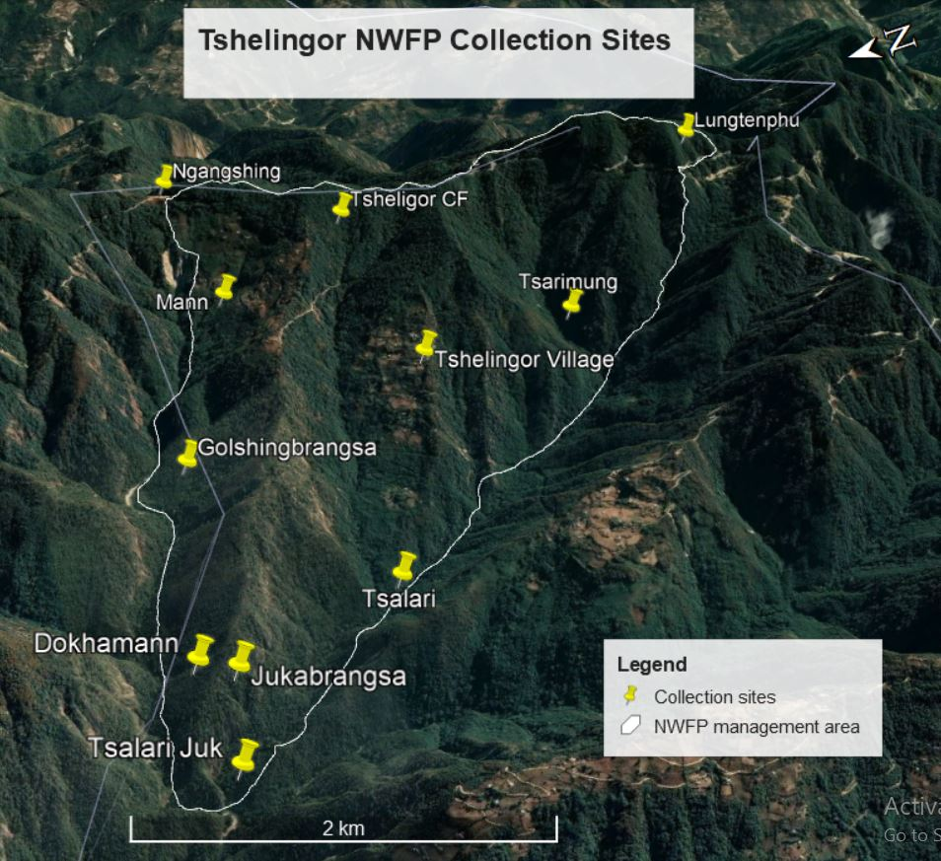
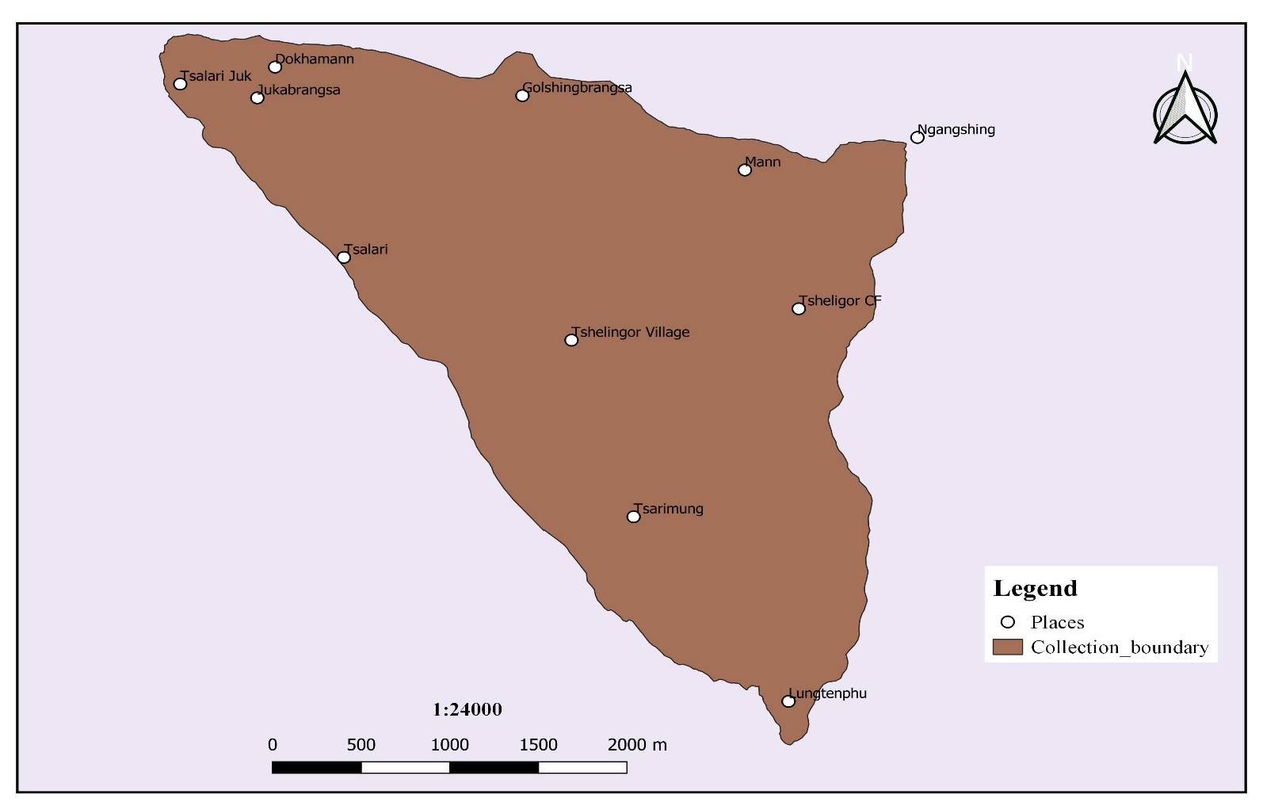

2.5: Marketing and sales plan

Table 3: Marketing and sales plan of NWFPs
NWFP name | Potential market | Estimated quantity for sale per season | Expected price per unit | Total Nu.
Youngjuva (Pouzolzia sanguine) | Local Trader | 500 kg | 30/kg | 15000
Lanyee roo (Rubia cordifolia) | Local trader | 1000 kg | 50/kg | 50000
Nyaishing Jurma (Viscum nepalense) | Local trader and local market | 10 kg | 650/kg | 6500
Shogoshing  (Daphne bholua) | Local trader | 1000 kg | 45/kg | 45000
Silungshing (Parasassafras confertiflora) | Local Market | 100 kg | 450/kg (14 kg, raw material | 45000
Ngonchanglu (Swertia chirata) | Local trader | 200 kg | 50/kg | 10000

2.5. Collection and Marketing arrangement with the group and traders
- The committee members are fully responsible for obtaining the collection permit from the nearest forest office a week ahead of the collection time. Then the committee shall announce the starting date, the duration of collection and the closing date as per the harvesting season.
- The individual members will collect and store the NWFP properly. The members will segregate products as per the standards required by the trader. Drying and packaging shall be in the individual houses. The members shall carry and bring the NWFPs product to the auction yard and Committee members shall inform to the concern forestry official/DAMC.

2.6: Marketing arrangements
The Committee members will look for the possible traders in consultation with concerned Forest Offices to sell their NWFP. If traders are not willing to buy the products, the concerned Forest Office will consult with Department of Agriculture and Marketing cooperatives (DAMC). Otherwise, following procedure will be followed while marketing:
- The Committee members and concerned Forest Office will carry out the preliminary assessment of availability of NWFP in the designated areas one months ahead of collection time/period.
- The Group members will collect the NWFP from the designated sites within a particular season based on the guidelines upon obtaining collection permit
- The group will submit the report on quantity of NWFP products collected to the Dzongkhag level NWFP Committee and concerned Forest Office.
- The Dzongkhag level NWFP Cluster Committee will talk and arrange with traders and announce the place and time of auction.
- The group will bring the NWFP products to the identified auction sites one day ahead of the fixed auction date.
The concerned committee in collaboration with DAMC will then organize NWFPs auction to various NWFPs traders. The auction will be organized in the presence of committee members from the respective NWFPs groups as a representative on behalf of the group.
The committee members shall deduct (5%) the expenditure such as transportation, community fund and compensation before making payment to the individuals. The date of marketing may/shall be conducted at the end of the fiscal year but it may vary with circumstances.
The dividing of saving money among group members will be done only when the saving amount exceeds Nu. 50,000 in their group account.

PART 3: BY-LAWS GROUP REGULATIONS AND NORMS

3.1. Members of the NWFP management & marketing group

3.1.1. Eligibility criteria to become member
- Existing community forest members are members of the NWFP group.
- The entire household having “Thram and Gung” under the Chiwog are eligible to join the group, provided they joined the CFMG.
- Any members can join as a new member upon depositing the sum equivalent to the individual share accumulated in the bank at the time of joining

3.1.2. Admission procedures for new members
- Shall fulfil the PART 3, subsection 3.1.1 and may apply to application to the Chairman for registration.
- During general meeting chairman shall discuss with the group regarding the acceptance or rejection of the membership. It will be based on the general consensus of all the members.
- Registration will take place if all above mentioned criteria are fulfilled

3.1.3. Resignation of members
- Any members resigning from group with loss of interest shall apply to Chairman and with immediate effect resignation shall be done without any benefit.
- Any members resigning from the group due to labour shortage/disability/other misfortune shall apply to chairman. Acceptance will be based on the general consensus of the members during meeting. The claim of 70% share from the shall be entertained.
- Dismiss of active member due to unavoidable circumstances can be replaced by its close relative from same Gung. If not 100% of his/her share will be entertained.

3.2. Committee members
Name | Designation | Gender | Phone
Mr. Tempa Gyeltshen | Chairperson | Male | 17822973
Mr. Dorji | Secretary: | Male | 17766216
Mr. Chogyal | Treasurer | Male | 17522039

3.3. Terms of reference for committee members

3.3.1. Responsibilities of Committee / Chairperson:
- To chair all kinds of meeting relating to NWFPs management matter in the group.
- To resolves the disputes and conflict among the members.
- To enforce the fine and penalty.
- To obtain collection permits from the nearest forest office a week ahead of the collection time
- To explore market for the products
- Fix date of collection and make an announcement to the group member
- Maintain contacts with traders, to arrange & coordinate marketing of NWFPs and record data, etc.
- To submit the annual report to the concerned Gewog RO.

3.3.2. Responsibilities of Secretary:
- Provide assistance to the Chairman.
- Officiate as Chairperson during his absence.
- Maintain records of the activities implemented, and also minutes of meeting.
- Write official correspondence.
- Compile the progress annual report and submit to chairman to further submit to forest office.
- Assist chairman and the treasurer in functioning the group smoothly

3.3.3. Responsibilities of Treasurer:
- To maintain all the financial record and present the details of funds to the group members during the general meeting.
- Officiate as Chairperson or Secretary in their absence.
- Maintain the cash transaction record, submit expenditure and cash balance report to Chairman and present it to the group in meetings.
- Collection of membership fee from the group members.
- Taking care of financial arrangements in the group
- Collect fines and penalties imposed by Chairman and Secretary

3.3.4. Responsibilities and rights of members:
- The group members participating in this management of NWFP will have equal rights and responsibilities for controlling, protection, management and harvesting in the identified collection areas.
- The individual members will not have the equal rights to collect and harvest at their own will unless the committee fixed the date.
- Every member of the group will have equal access to report to the committee members for violation of the management rules.
- The members should agree to sell the collections only through the group and not individually.
- Withdrawal of any group members without genuine reason will be allowed with no benefits from accumulated fund and no re-entry will be entertained.

3.3.4. Resignation of committee members
- If committee members resign due to unavoidable circumstances all the members will discuss during the general meeting and come into common consensus. From the date of acceptance of resignation, he/she shall participate as a member.

3.3.5. Termination of committee members
- The committee members shall be terminated if he/she is accused of fraud or financial malpractices of group fund
- He/she shall repay the amount within a month from the date of knowledge by any members with 5% of for the amount misused and shall vacate the post.
- If repayment is not done during the stipulated time, defaulters shall be dealt as per the by-laws of conflict resolution.

3.4. Compensation to the committee or any other office bearers
- There is no compensation for the committee members. Based on the availability of budget the compensation for the committee members will be decided during the annual general meeting.

3.5. Membership fee and purpose
- Membership fee for the existing group should pay Nu. 50/- annually.
- Any new members wishing to join the group may be allowed after he/she paying the amount equal to the share that each members get from the total saving of the group.
- The collected fee will be deposited in the joint account of the group.

3.6. Community development fund and utilization of fund

I. Income contribution to group fund
- The members should contribute 5% of the total income generated from the sale of each product.

II. Fund management
- The cash collected should be deposited in the group account in the bank and maintained proper record by the committee members.
- The bank account will be operated by Chairman, Secretary and Treasurer, and they are signatory authority of the Bank Account.
- All expenditure incurred on behalf of the group will be beard from the Joint Account. Technical support will be sought from the concerned Forest officials.
- The source of fund will be from fine imposition, membership fees and the selling of NWFP
- The group members will deposit 5% of the amount earned from the sale of the any NWFP products individually irrespective of the price fluctuation.

III. Fund utilization
- From the total budget saved in the group account will be utilized for the group works upon general agreement. In case of huge amount accumulation in the account the amount will be equally shared among the members.

3.7. Conflict Resolution
- In case disputes or conflicts among members arise in regards to NWFP management shall be forwarded to Chairman for settlement. If the case cannot be resolved, the matter shall be forwarded to Gewog Administration for further decision.
- In case there is a conflict between the NWFP Group and outsiders, the case shall be forwarded to the Forest Office.
- The conflict/issues arising among the group members regarding NWFP matters will resort firstly to the Chairman usually during the annual meeting (group activities) before NWFP collection starts.
- Still if the conflict remains unresolved the case will be forwarded to the Gewog Administration.
- If the Gewog Administration cannot have resolved the problems, the case will be forwarded to the Divisional Forest Office for further action

3.8. Offences and Penalties
- In case if the member of the NWFP Group violates the harvesting rules as set in this plan, he or she will not be allowed to harvest the NWFP for the rest of the season.
- Members collecting the NWFP prior to the fixed date/announcement made by the Committee / GEFO, the offender will be levied fine Nu. 1000/- and product will be seized by the group
- Number of days for the collection will depend on availability of resources and general consensus by the members.
- Non-members without registering will be not allowed to collect and fine of Nu. 3000/- irrespective of products and product will be seized to the group.
- An absentee during meeting is liable to pay Nu. 100/- per head.
- If product is sold illegally the penalty will be the double of the price sold
- An absentee during work is liable to pay Nu. 100/- per head.
- An absentee owing to death, sick or other genuine reasons are considered only after the approval from Chairperson. If he/she did not inform to the committee members, they will be liable fine.

Members list

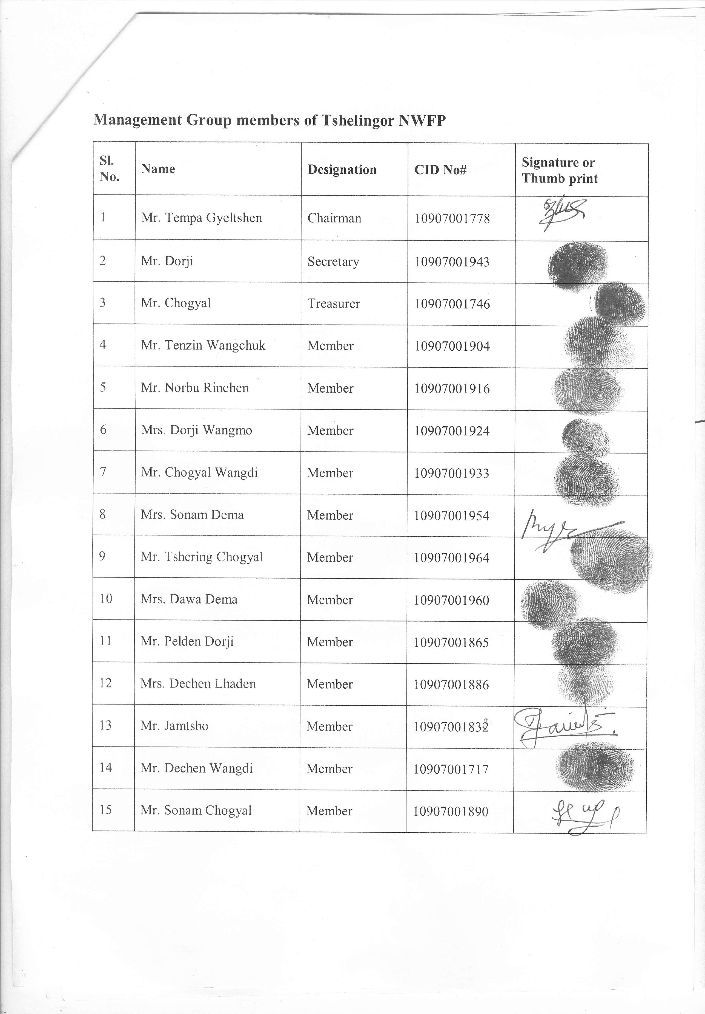
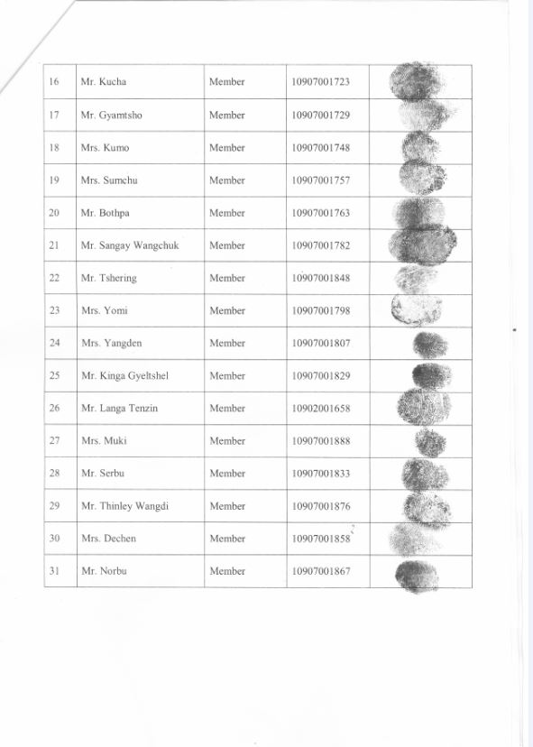

3.9. Past five years NWFP Harvesting Record for the group
Sl. No. | Types of Product | Year | Quantity | Remarks
1 | Rubia cordifolia | 2016 | 305 kg
2 | Pouzolzia sanguine | 2017 | 70 kg
3 | Viscum nepalense | 2017 | 25 kg
4 | Rubia cordifolia | 2017 | 153 kg
5 | Rubia cordifolia | 2019 | 300 kg
6 | Viscum nepalense | 2019 | 32 kg

